FINAL REPORT
SGA2 – Software Development Practices
Name: Ashfaaq Feroz Muhammad
ID: 2023EBCS005
Year: 2025

QUESTION 1 — GIT & GITHUB

2.1 (1a) Local Git Repository Setup
A simple static website was created with index.html, about.html, contact.html, and style.css.
Git was initialized using:
git init

2.2 (1b) Demonstration of Git Commands
Commands demonstrated:
git status
git add .
git commit -m "Initial commit"
git log --oneline -n 3
git branch feature/update-readme
git switch feature/update-readme
git switch main

2.3 (1c) GitHub Integration
The repository was created in GitHub and connected via:
git remote add origin <repo-url>
git push -u origin main

GitHub Repository Link:
https://github.com/ashfaaqkt/devops-assignment-starter

QUESTION 2 — DOCKER

1.1 (2a) Custom Docker Image
A Python Flask application was created to print:
Hello, World! 👋 (served from a Docker container)

Dockerfile used:
FROM python:3.12-slim
WORKDIR /app
RUN python -m pip install --upgrade pip && python -m pip install flask==3.0.3 --no-cache-dir
COPY app.py /app/app.py
EXPOSE 8080
CMD ["python", "app.py"]

1.2 (2b) Build the Docker Image
The Docker image was built using:
docker build --no-cache -t ashfaaqkt/hello-app:1.0 .

1.3 (2c) Push the Image to Docker Hub
Commands:
docker login
docker tag ashfaaqkt/hello-app:1.0 ashfaaqkt/hello-app:latest
docker push ashfaaqkt/hello-app:1.0
docker push ashfaaqkt/hello-app:latest

Docker Hub Link:
https://hub.docker.com/repository/docker/ashfaaqkt/hello-app

2.4 (2d) Run the Container Locally
Commands:
docker run -d -p 8080:8080 --name hello1 ashfaaqkt/hello-app:1.0
docker ps
Application accessed at:
http://localhost:8080

Conclusion
This assignment successfully demonstrates Git version control, GitHub integration, Docker image creation, containerization, and running a web application inside a Docker container. These are key DevOps principles used in modern CI/CD workflows.

Screenshots
Screenshots is available in individual folder also for better view

Q1a – Git Init & Status
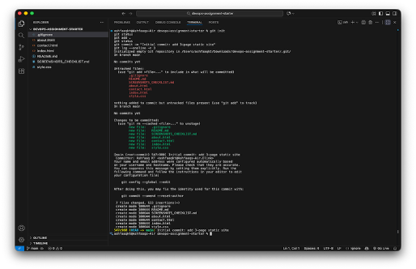

Q1b – Git Add & Commit
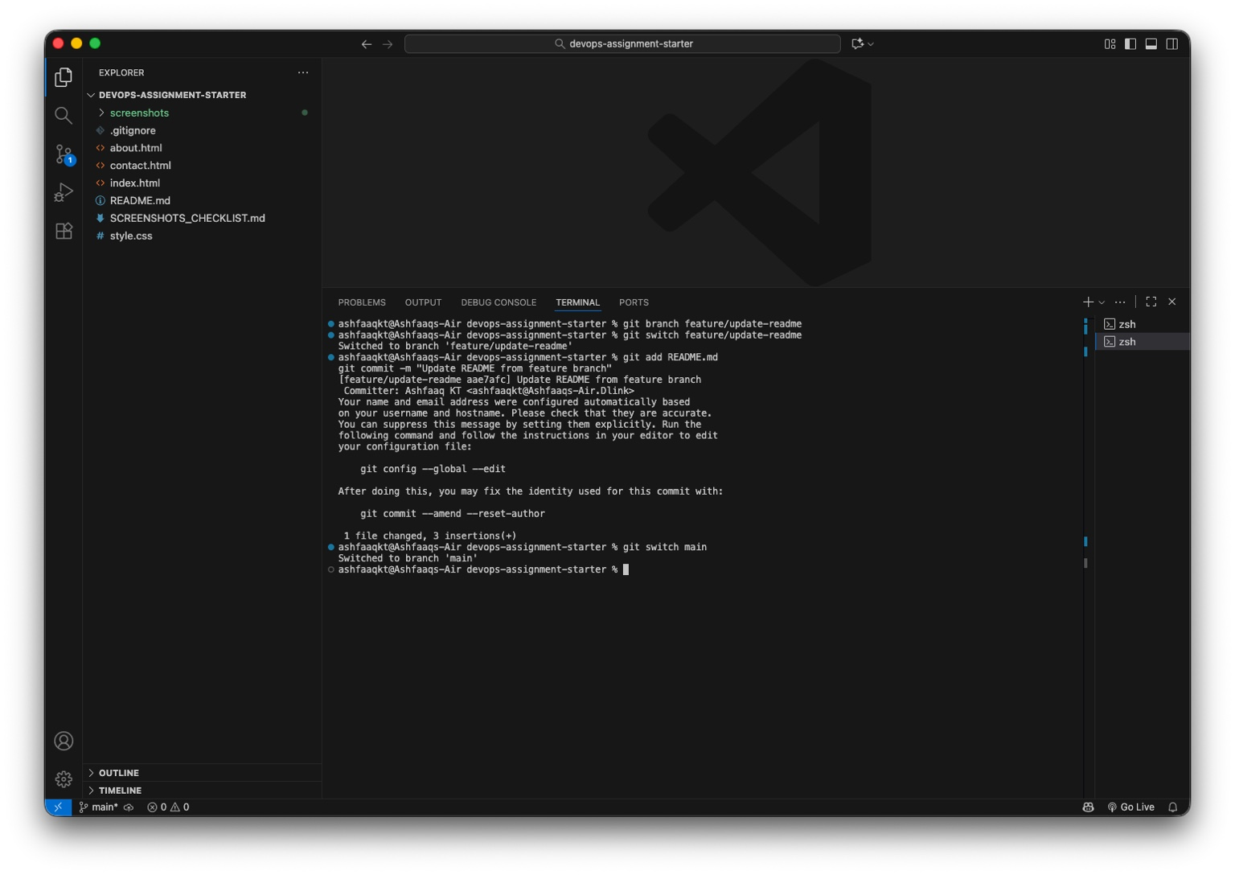

Q1c – GitHub Repo Page
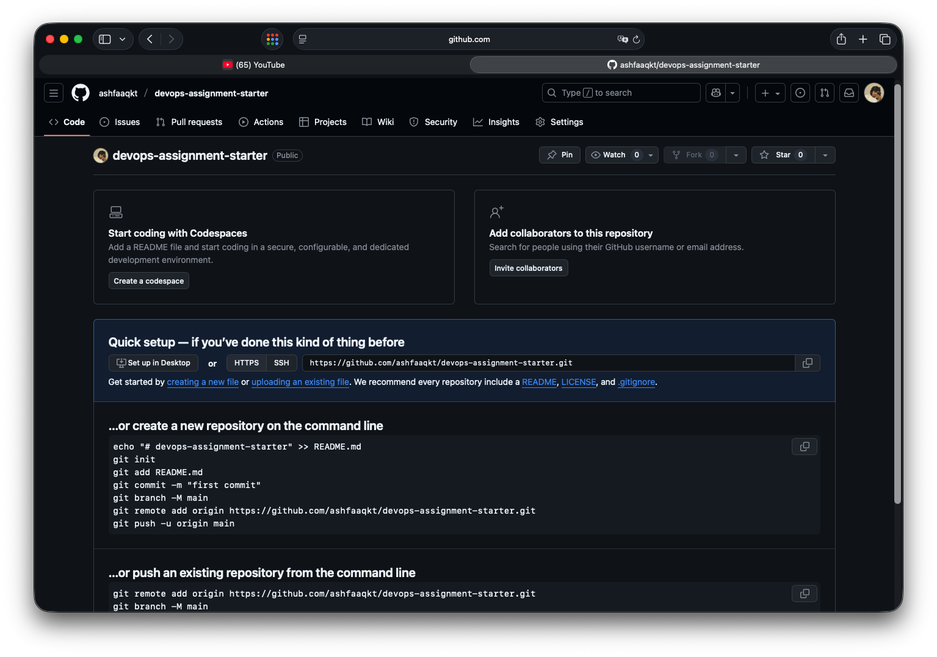

Q1c – Remote Verification
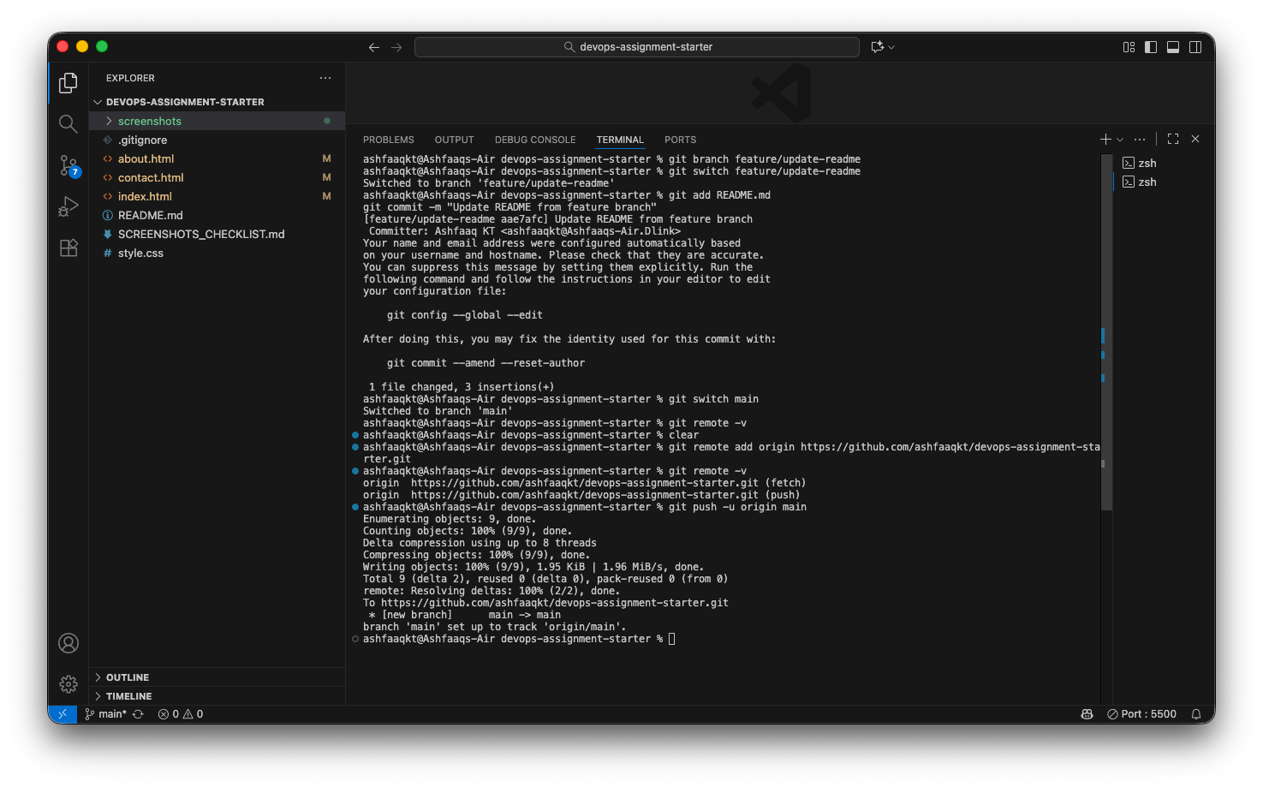

Docker Hub Repository
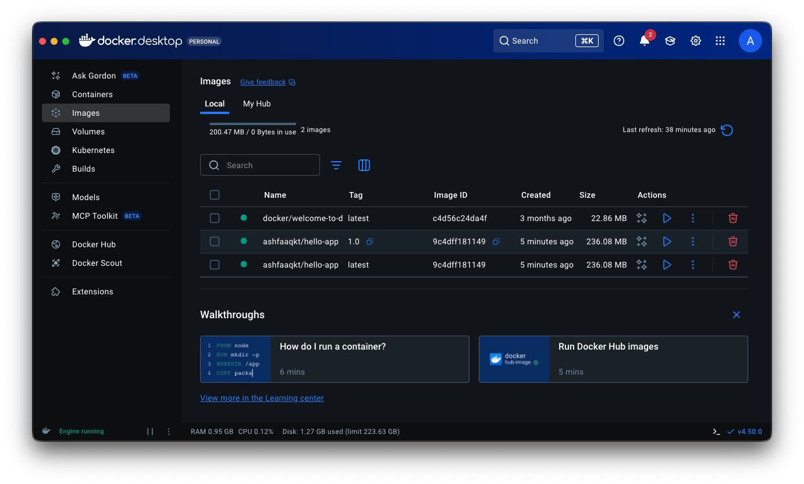

Docker Login Confirmation
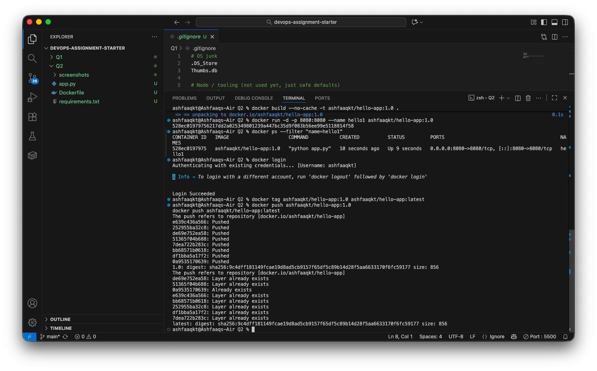

Docker Images List
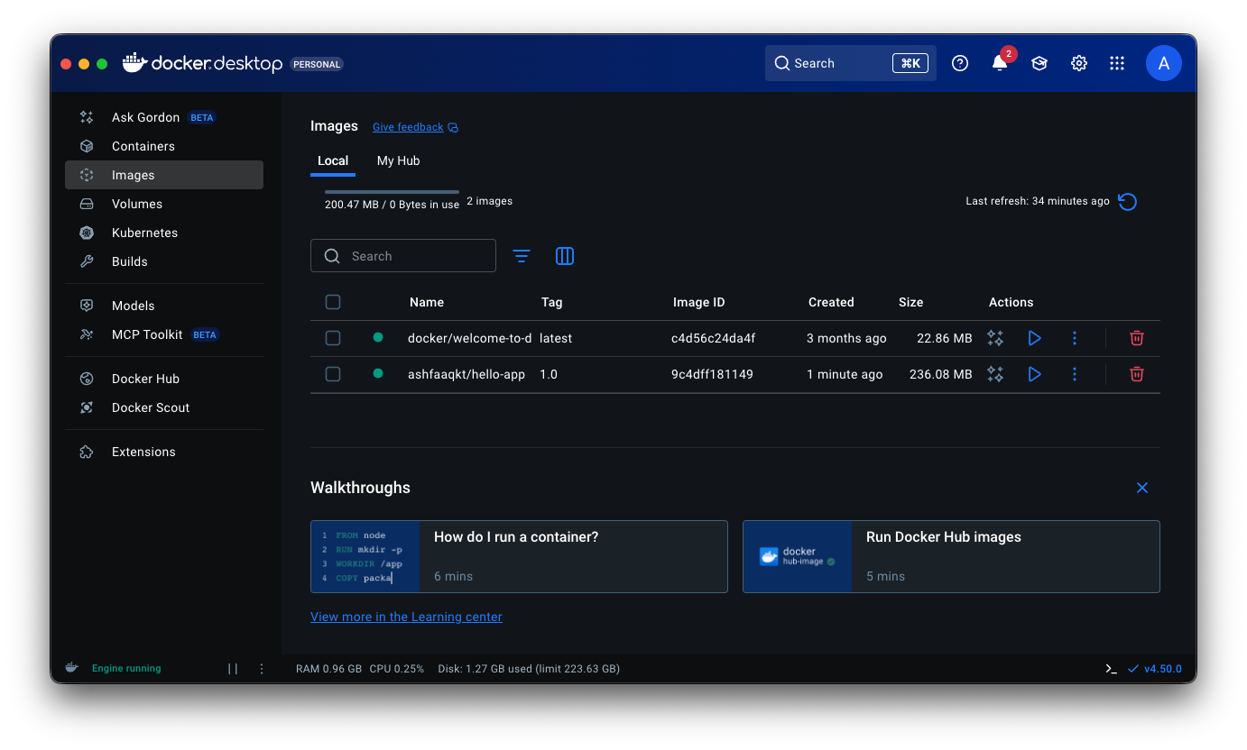

Q2a – Flask App Code
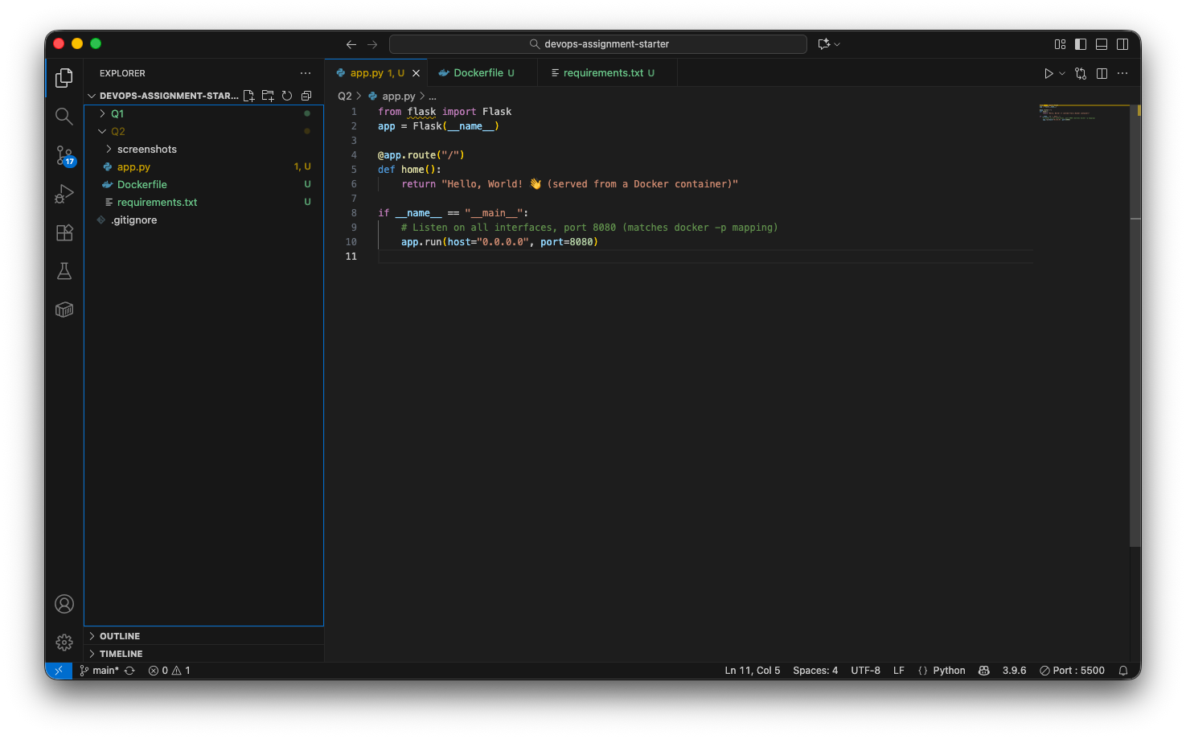

Q2b – Dockerfile Build
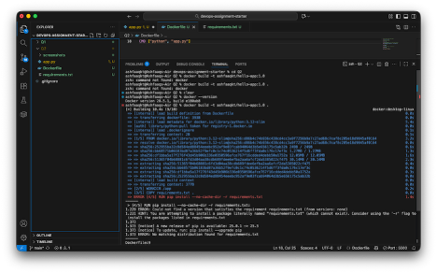

Application Running in Browser
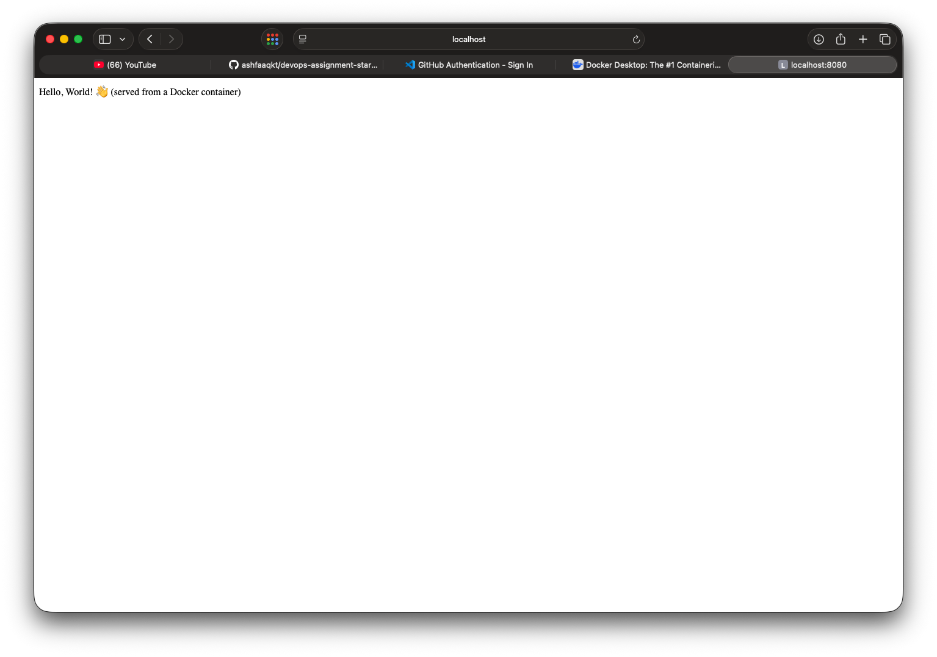

The END

